|  |  |
| --- | --- |
|  | Exercise 1. Tracing router route |
|  |  |
|  | Akshar Panchani ID- 202101522  IT304 Computer Networks  8/11/23 |



**Reading 1:**

**Location:** **172.217.167.174-> Chicago, United States**

**Average time: 20ms**

|  |  |  |  |  |  |  |  |
| --- | --- | --- | --- | --- | --- | --- | --- |
| Sr.No | Ping1 | Ping2 | Ping3 | IP address |  |  |  |
| 1 | 3 ms | 1 ms | 8 ms | 10.200.0.4 |  |  |  |
| 2 | 3 ms | 6 ms | 2 ms | 10.100.56.55 |  |  |  |
| 3 | 12 ms | 68 ms | 16 ms | 10.119.237.21 |  |  |  |
| 4 | 58 ms | 70 ms | 19 ms | 10.154.7.49 |  |  |  |
| 5 | 15 ms | 16 ms | 17 ms | 10.255.236.161 |  |  |  |
| 6 | 15 ms | 15 ms | 15 ms | 10.152.7.214 |  |  |  |
| 7 | 25 ms | 27 ms | 18 ms | 72.14.204.62 |  |  |  |
| 8 | 17 ms | 96 ms | 18 ms | 72.14.239.103 |  |  |  |
| 9 | 18 ms | 17 ms | 17 ms | 108.170.232.205 |  |  |  |
| 10 | 27 ms | 18 ms | 28 ms | bom12s01-in-f14 | .1e100.net [172.217.167.174] | | |

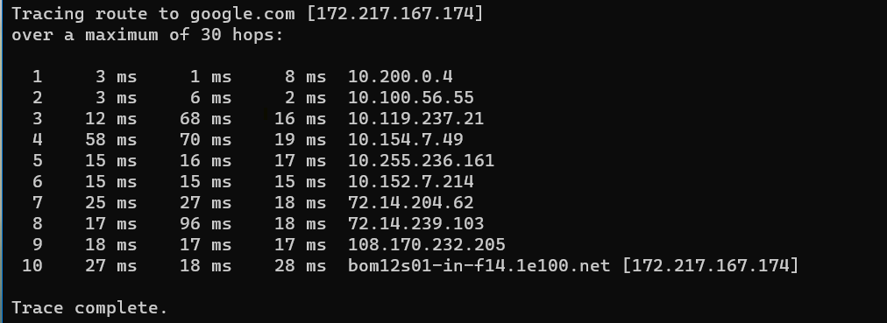

**Reading 2:**

**Location:** **142.251.42.110 -> Marriottsville, Maryland ,United States**

**Average time: 18ms**

|  |  |  |  |  |  |  |  |
| --- | --- | --- | --- | --- | --- | --- | --- |
| Sr.No | Ping1 | Ping2 | Ping3 | IP address |  |  |  |
| 1 | 2 ms | 1 ms | 2 ms | 10.200.0.4 |  |  |  |
| 2 | 2 ms | 2 ms | 3 ms | 10.100.56.55 |  |  |  |
| 3 | 3 ms | 3 ms | 3 ms | 10.119.237.21 |  |  |  |
| 4 | 14 ms | 16 ms | 15 ms | 10.154.7.49 |  |  |  |
| 5 | 16 ms | 14 ms | 15 ms | 10.255.236.161 |  |  |  |
| 6 | 19 ms | 16 ms | 15 ms | 10.152.7.214 |  |  |  |
| 7 | 22 ms | 23 ms | 16 ms | 72.14.204.62 |  |  |  |
| 8 | 23 ms | 19 ms | 19 ms | 142.251.76.27 |  |  |  |
| 9 | 19 ms | 19 ms | 22 ms | 142.251.77.97 |  |  |  |
| 10 | 31 ms | 19 ms | 16 ms | bom07s45-in-f1 | 4.1e100.net [142.251.42.110] | | |

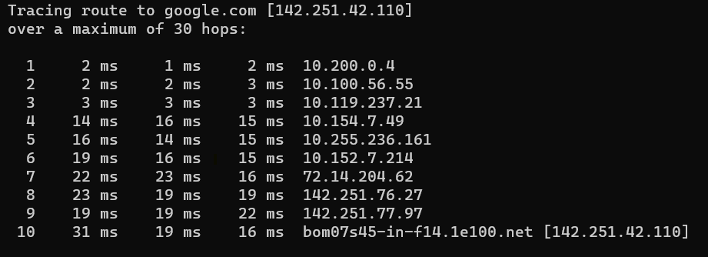

**Reading 3:**

**Location: 142.251.42.14 -> Marriottsville, Maryland ,United States**

**Average time: 16ms**

|  |  |  |  |  |  |  |  |
| --- | --- | --- | --- | --- | --- | --- | --- |
| Sr.No | Ping1 | Ping2 | Ping3 | IP address |  |  |  |
| 1 | 2 ms | 2 ms | 2 ms | 10.200.0.4 |  |  |  |
| 2 | 2 ms | 2 ms | 2 ms | 10.100.56.55 |  |  |  |
| 3 | 4 ms | 2 ms | 2 ms | 10.119.237.21 |  |  |  |
| 4 | 16 ms | 22 ms | 19 ms | 10.154.7.49 |  |  |  |
| 5 | 17 ms | 18 ms | 18 ms | 10.255.236.161 |  |  |  |
| 6 | 19 ms | 20 ms | 21 ms | 10.152.7.214 |  |  |  |
| 7 | 16 ms | 17 ms | 17 ms | 72.14.204.62 |  |  |  |
| 8 | 19 ms | 18 ms | 16 ms | 142.251.49.177 |  |  |  |
| 9 | 27 ms | 19 ms | 26 ms | 209.85.248.61 |  |  |  |
| 10 | 16 ms | 17 ms | 21 ms | bom12s19-in-f14 | .1e100.net [142.251.42.14] | | |

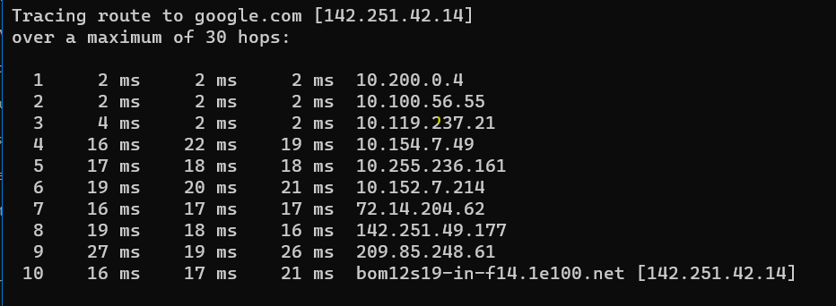

**Reading 4:**

**Location: 142.251.42.110 ->** **Marriottsville, Maryland ,United States**

**Average time: 25ms**

|  |  |  |  |  |  |  |  |
| --- | --- | --- | --- | --- | --- | --- | --- |
| Sr.No | Ping1 | Ping2 | Ping3 | IP address |  |  |  |
| 1 | 2 ms | 2 ms | 2 ms | 10.200.0.4 |  |  |  |
| 2 | 2 ms | 1 ms | 1 ms | 10.100.56.55 |  |  |  |
| 3 | 4 ms | 3 ms | 5 ms | 10.119.237.21 |  |  |  |
| 4 | 16 ms | 15 ms | 16 ms | 10.154.7.49 |  |  |  |
| 5 | 20 ms | 16 ms | 16 ms | 10.255.236.161 |  |  |  |
| 6 | 15 ms | 15 ms | 18 ms | 10.152.7.214 |  |  |  |
| 7 | 18 ms | 17 ms | 16 ms | 72.14.204.62 |  |  |  |
| 8 | 22 ms | 20 ms | 19 ms | 142.251.76.27 |  |  |  |
| 9 | 19 ms | 19 ms | 19 ms | 142.251.77.97 |  |  |  |
| 10 | 17 ms | 17 ms | 17 ms | bom07s45-in-f14 | .1e100.net [142.251.42.110] | | |

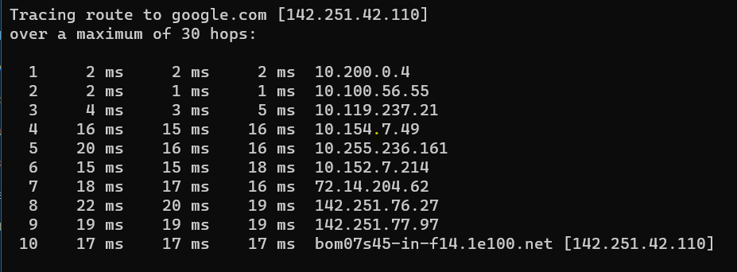

**Reading 5:**

**Location: 115.247.69.85->Mumbai,India**

**Average time: 211ms**

|  |  |  |  |  |
| --- | --- | --- | --- | --- |
| Sr.No | Ping1 | Ping2 | Ping3 | IP address |
| 1 | 1 ms | 1 ms | 1 ms | 10.200.0.4 |
| 2 | 2 ms | 4 ms | 2 ms | 10.100.56.55 |
| 3 | 3 ms | 2 ms | 5 ms | 10.119.237.21 |
| 4 | * | * | * | Request timed out. |
| 5 | * | * | * | Request timed out. |
| 6 | 22 ms | 19 ms | 20 ms | 10.152.7.38 |
| 7 | 18 ms | 18 ms | 18 ms | 115.247.69.85 |
| 8 | * | * | * | Request timed out. |
| 9 | * | * | * | Request timed out. |
| 10 | * | * | * | Request timed out. |
| 11 | * | * | * | Request timed out. |
| 12 | * | * | * | Request timed out. |
| 13 | * | * | * | Request timed out. |
| 14 | * | * | * | Request timed out. |
| 15 | * | * | * | Request timed out. |
| 16 | * | * | * | Request timed out. |
| 17 | * | * | * | Request timed out. |
| 18 | * | * | * | Request timed out. |

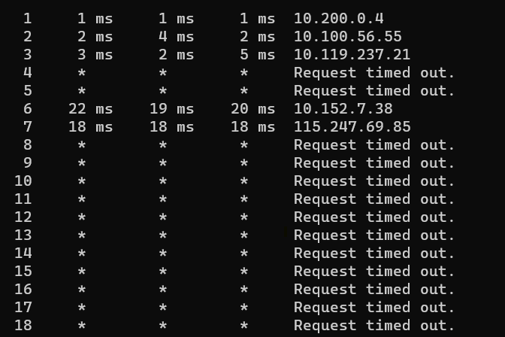

**Reading 6:**

**Location: 104.244.42.65 ->Chicago,United States**

**Average time: 69ms**

|  |  |  |  |  |  |
| --- | --- | --- | --- | --- | --- |
| Sr.No | Ping1 | Ping2 | Ping3 | IP address |  |
| 1 | 2 ms | 2 ms | 1 ms | 10.200.0.4 |  |
| 2 | 3 ms | 6 ms | 5 ms | 10.100.56.55 |  |
| 3 | 1 ms | 4 ms | 6 ms | 10.119.237.21 |  |
| 4 | * | * | * | Request timed out. |  |
| 5 | * | * | * | Request timed out. |  |
| 6 | 21 ms | 20 ms | 18 ms | 10.152.7.38 |  |
| 7 | 21 ms | 19 ms | 20 ms | 115.247.69.85 |  |
| 8 | * | * | * | Request timed out. |  |
| 9 | * | * | * | Request timed out. |  |
| 10 | * | * | * | Request timed out. |  |
| 11 | * | * | * | Request timed out. |  |
| 12 | 70 ms | 73 ms | 73 ms | r-199-59-151-96.tw | [199.59.151.96] |
| 13 | 70 ms | 70 ms | 70 ms | 104.244.42.65 |  |

